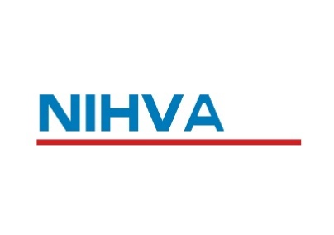
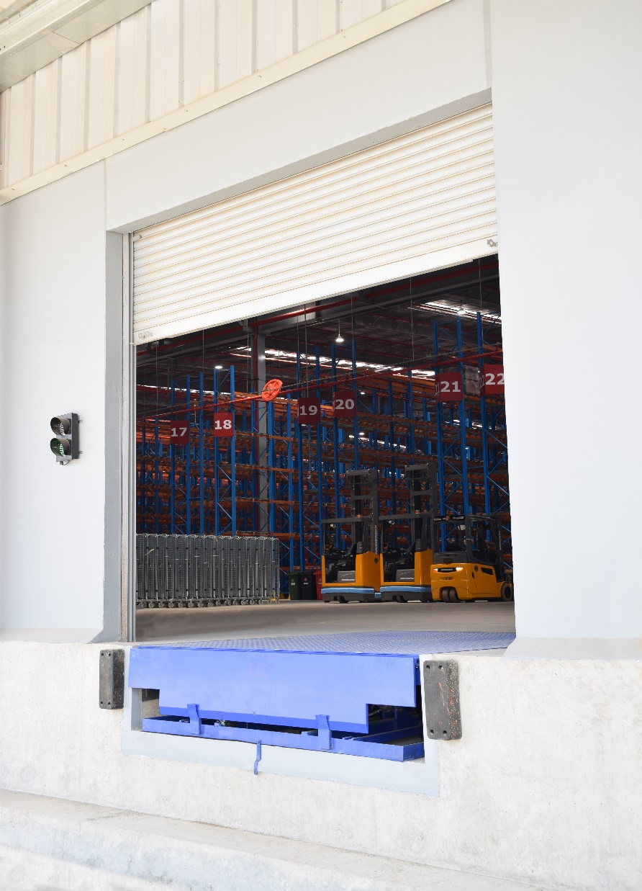
NIHVA DOCK LEVELLER

NIHVA USP :-
- Our dock levellers can be customized to fit various truck heights, load capacities, and specific warehouse requirements.

- Ensure smooth loading and unloading for any type of transport vehicle.

- Our dock levellers are engineered for: Heavy loads & harsh conditions.

- Long-lasting performance means fewer maintenance hassles.

- Our hydraulic power ramp dock levellers ensure: Minimal downtime & Maximum productivity

- Easy installation process.

- Minimal upkeep, allowing you to focus on core operations.

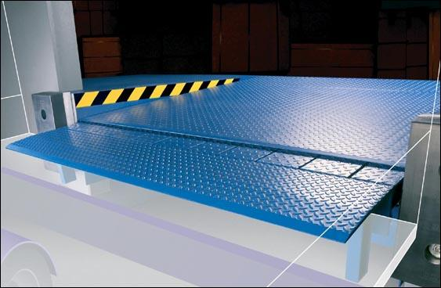
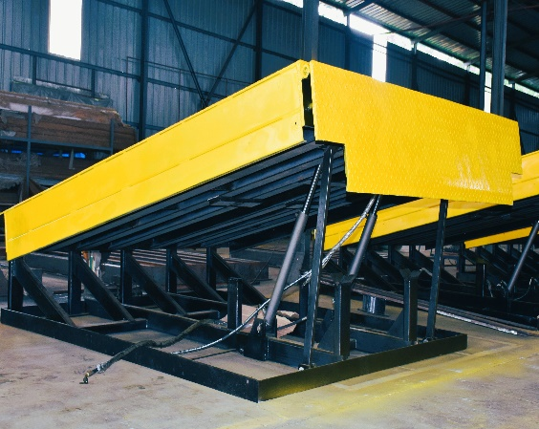
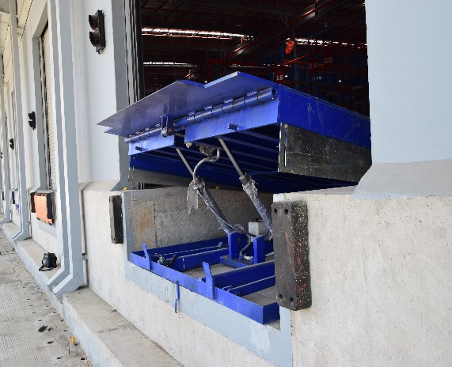


www.nihva.com
www.shivaah.com


sales@nihva.com
+91 2066 3040 33
+91 85 51091 333
www.nihva.com
www.shivaah.com
Technical Specifications for NIHVA Make Dock Leveller – 6 Ton
NIHVA DOCK LEVELLER

Sr. No. | Description | Specifications
1 | Capacity | Capacity is 6 Ton and Point Load is 2 Ton
2 | Dock operation mode | AC power pack hydraulically operated
3 | Lip operation mode | Hydraulic
4 | Operation control | Through panel
5 | Loading platform height from road | 1250mm
6 | Travel above & below dock level | (+) 300 / (-) 150 mm
7 | Platform Size (W x L) | 2250 mm x 2250 mm
8 | Lip size (W x L ) | 2250 x 400 mm
9 | Shut Height | 480 mm
10 | Working length | 2650 mm
11 | Overall Length | 2250mm x2250mm + Lip Length (400mm)
12 | Maximum slope can be achieved | 10%
13 | Clear Pit dimensions (W x L x D) | (W) 2300mm x (L) 2300 mm x (D) 485 mm
14 | Hydraulic power pack | Standard
15 | Driver type | Direct by electric Motor
16 | Motor Ratings | 1 H.P
17 | Pump design flow | 2.5 LPM
18 | Pump pressure | 120 bar Operating 200 bar Max
19 | Safety valve set pressure | 120 Kg/cm²
20 | Pump Type | Gear
21 | Volume of oil receiver | 7 Lit
22 | No Of Deck cylinder | 2 No
23 | Lip Cylinder | 1 No
24 | Dock Bumper | Included

sales@nihva.com
+91 2066 3040 33
+91 85 51091 333
www.nihva.com
www.shivaah.com

